**Interactive Programming Using Python**

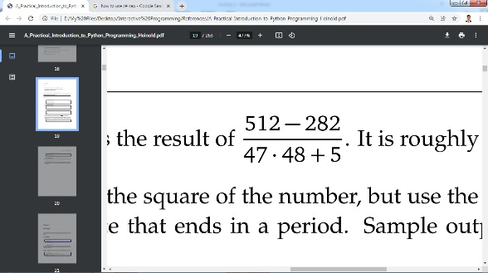**Laboratory Activity #2**

1. Write a program that computes and prints the result of it is roughly .1017.
2. Write a program that asks the user for a weight in kilograms and converts it to pounds. There are 2.2 pounds in a kilogram.
3. Write a program that asks the user to enter three numbers (use three separate input statements). Create variables called total and average that hold the sum and average of the three numbers and print out the values of total and average.

Prepared by:

**Mar Riel C. Abuke**

*I.T Faculty*